spring 2025
Cse-4377 wireless communication systems
the university of texas at arlington


lab 2 report
Submitted toward the partial completion of the requirements for CSE 4377
Under the guidance of
Prof. Jason Losh
By:
Joshua Martinez, 1001374818

Introduction
This lab covers clipping and compression within wireless communications, extended upon a previous lab. Both sections require generating IQ signals via a TM4C microcontroller with its specialized circuit, an RF signal generator with external IQ modulation inputs, an RF amplifier, and an RF spectrum analyzer. The first section of this lab focuses on observing the effects of a clipped signal affecting the signal within the spectrum analyzer; whereas the second section displays the effect of an RF amplifier when it is given an input exceeding its limits, shown on the spectrum analyzer. Overall, this lab provides experience with certain limitations within RF signals and their circuit designs within wireless systems.

Steps 1-8: Clipping
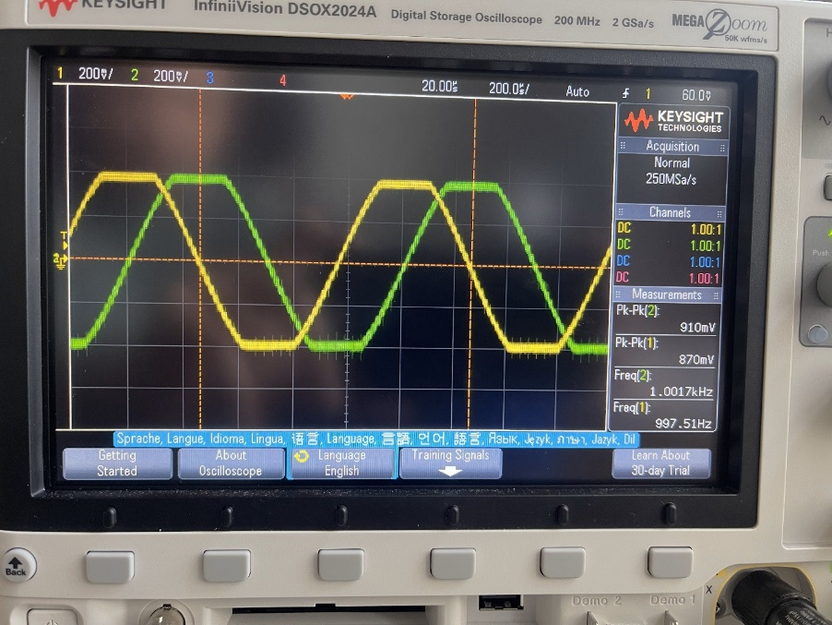
To begin, the same circuit and code from lab 1 is required to create the I and Q signals with 0.5Vrms and 10 kHz, as well as diodes across the I and Q inputs of the signal generator to prevent damage to the device. Next, the same settings of 100 MHz with a span of 100 kHz are required on the spectrum analyzer with a -20 dBm on the RF generator. Once everything is connected and the signal outputs onto the spectrum analyzer, we will need to gradually increase the amount of clipping on the IQ signals. This is done by adding threshold limits of the signals inputted from the shell command on the lab 1 code in a new command function. In other words, when a signal output would be higher than the set limit, the set limit would instead be output creating squared peaks. Based on a rough 50 mV clip increase intervals, we recorded the original -43 dBm from the original signals increase to around -15 dBm on the spectrum analyzer as the peak from clipping. The reason for the dBm increase is due to the increased harmonics introduced due to the clipping. The overall increasing measured power on the analyzer is due to the harmonic distortion which amplifies the signal up to a certain point. The following images were captured during this section of the lab.

Image 1: Oscilloscope view of clipping of the IQ signals from TM4C/DAC
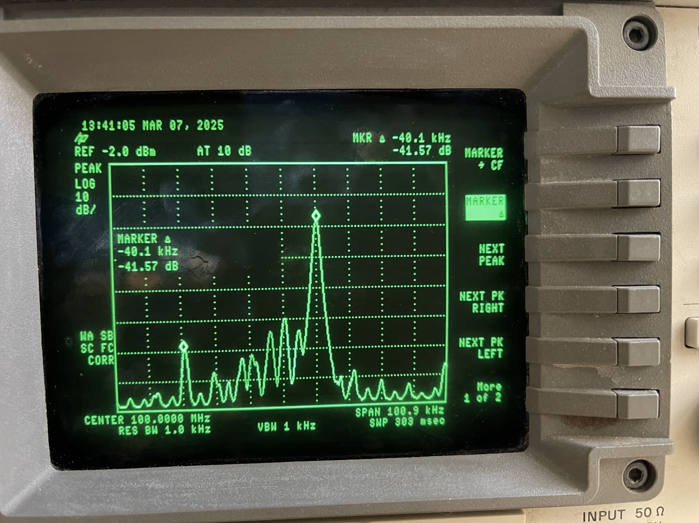
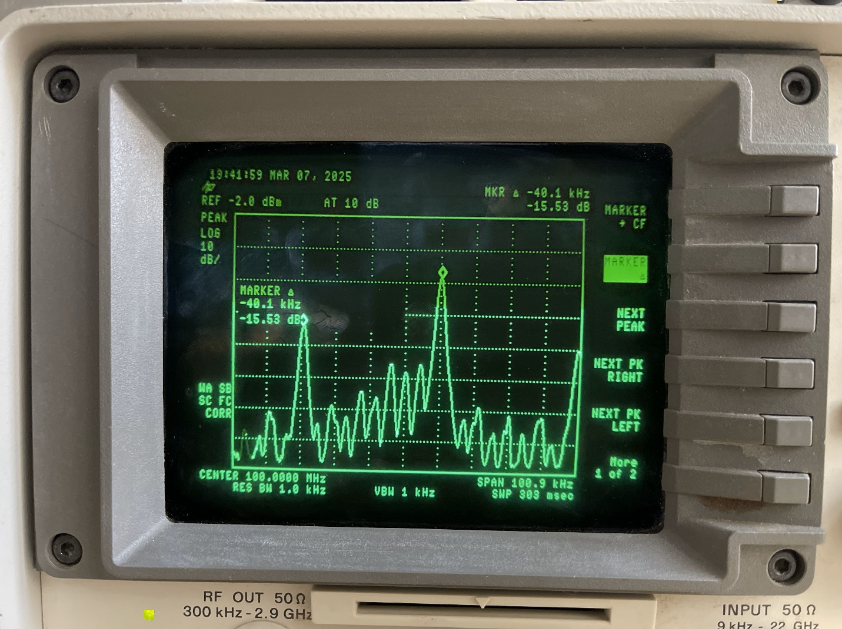
Image 2: Spectrum of IQ signals with minor clipping
Image 3: Spectrum of IQ signals with rough 750 mV clipping

Clip Value (mV) | dBm
0 | -43
50 | -31.3
100 | -27
150 | -24
200 | -21.5
250 | -20.75
300 | -19.2
350 | -18.5
400 | -18.2
450 | -18.2
500 | -18
550 | -18
600 | -17.8
650 | -17.2
700 | -16.5
750 | -15.5
800 | -15.4
850 | -18

Table 1: Clip Values (50 mV increments) and corresponding peak dBm

Steps 9 -20: Compression with Tone Input
The next section of the lab revolves around the same setup with IQ signals without clipping. An additional component for this lab is the low-noise SPF5189Z amplifier with a DC block which is connected between the RF signal generator and the spectrum analyzer, attached to a 5V power supply. The amplifier, after proper installation and safety precautions taken to prevent damage to the analyzer, created a rough 1dBm (~0.75) offset as shown in the image below on the peak measurement. On the amplifier’s datasheet, it notes it has a P1dB (1 dB compression point) at +22.7 dBm at 1960 MHz. In other words, this device will show a 1 dB compression, due to its power limitations, at around a 22 dBm increase. To verify this stat, we will increase the -20 dBm RF signal by 1dBm, ensuring not to surpass +3 dBm, and compare the analyzers peak value. A table below shows the results of our testing and notes a 1 dBm compression point occurs at around a +2 dBm output on the RF generator but the analyzer measures 0.25 (with the 0.75 offset, thus 1). Due to the starting point is -20 dBm with the result being +2 dBm, equating a +22 dBm increase, this matches the noted description on the datasheet and revealed the limits of the device.

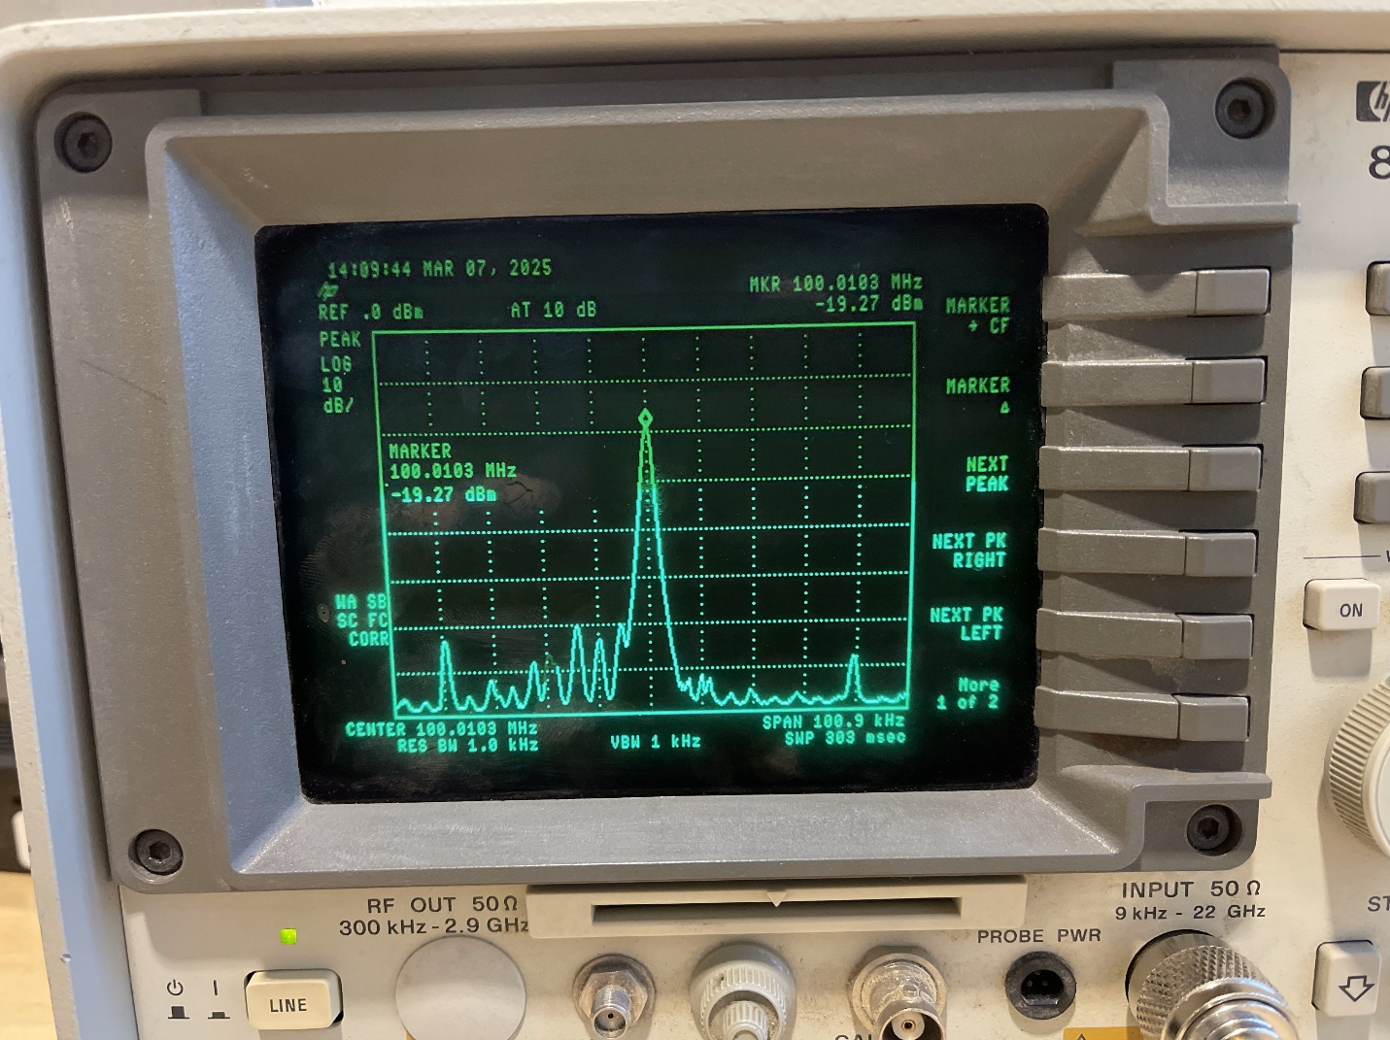
Image 4: Spectrum analyzer base measurement with Amplifier attached and RF generator at -20 dBm

Single Tone (0.75 Offset):
RF (dBm) | Spectrum (dBm)
-20 | -19.22
-19 | -18.25
-18 | -17.25
-17 | -16.25
-16 | -15.25
-15 | -14.25
-14 | -13.25
-13 | -12.25
-12 | -11.25
-11 | -10.25
-10 | -9.3
-9 | -8.3
-8 | -7.3
-7 | -6.32
-6 | -5.33
-5 | -4.36
-4 | -3.4
-3 | -2.4
-2 | -1.4
-1 | -0.56
0 | 0.04
1 | 0.3
2 | 0.25

Table 2: Measured value to verify the 1 dBm compression point of the amplifier

Steps 21-32: Compression with Two Tone Input
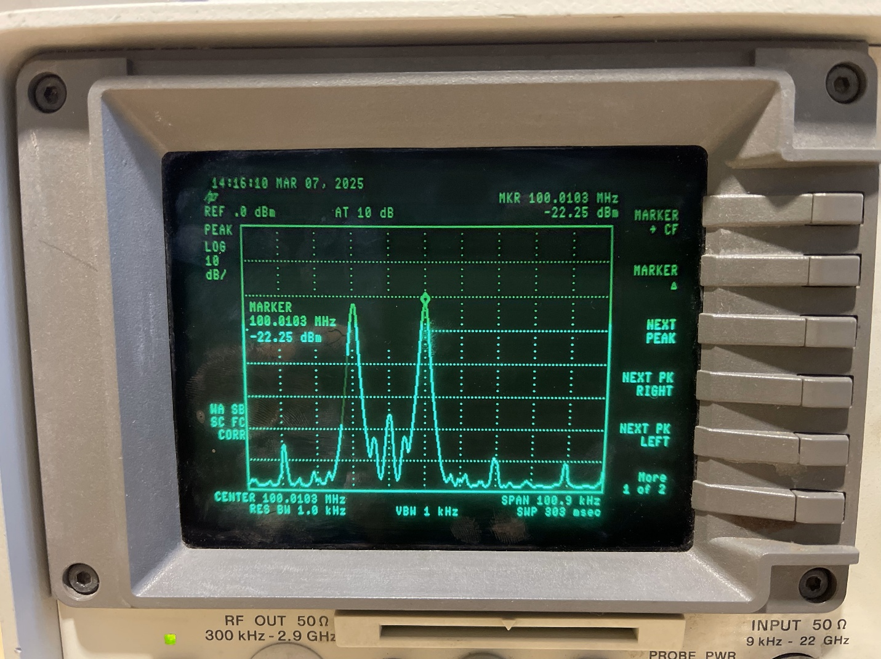
The last section of the lab involves a two-tone input instead of one, as in the previous section. This is done by disconnecting the Q signal so only the I signal is seen on the spectrum analyzer. Due to this disconnect creating the two peaks, the combined power equating the single tone is split between the new two-tone input leading to about a 3 dBm drop as shown on the image below. Similarly as the previous section, the RF signal generator will be increase in 1 dBm intervals so we may find the 1 dBm compression point of the amplifier. During testing, the 1 dBm compression point was to be found at around -1 dBm on the RF generator, roughly a 19 dBm increase with the 3 dBm offset due to the single signal input as shown on the table below.

Image 5: Spectrum analyzer base measurement with Amplifier attached and RF generator at -20 dBm with two-toned input
Double Tone (rough 2.5 offset):
RF (dBm) | Spectrum (dBm)
-20 | -22.25
-19 | -21.26
-18 | -20.25
-17 | -19.25
-16 | -18.3
-15 | -17.3
-14 | -16.3
-13 | -15.3
-12 | -14.3
-11 | -13.3
-10 | -12.3
-9 | -11.3
-8 | -10.35
-7 | -9.35
-6 | -8.4
-5 | -7.4
-4 | -6.5
-3 | -5.6
-2 | -4.96
-1 | -4.5
0 | -4.3

Table 3: Measured value to verify the 1 dBm compression point of the amplifier with two-toned input

Conclusion – Final
In conclusion, this lab revolved in understanding and implementing distortion and degrading effects in signals within wireless communications. The first being clipping which increases the harmonic distortion and spectral regrowth which is the expanded signals shown during the lab. The second section of this lab revolved around compression, or the nonlinear gain from the amplifier due to power limitations. This resulted in the expected and actual results varying in terms of the transmitted signals creating compression. Overall, these are issues to take into consideration when it comes to transmitting signals that alter them if you’re not careful. The following images include the entire lab setup, and the amplifier used for the compression sections.

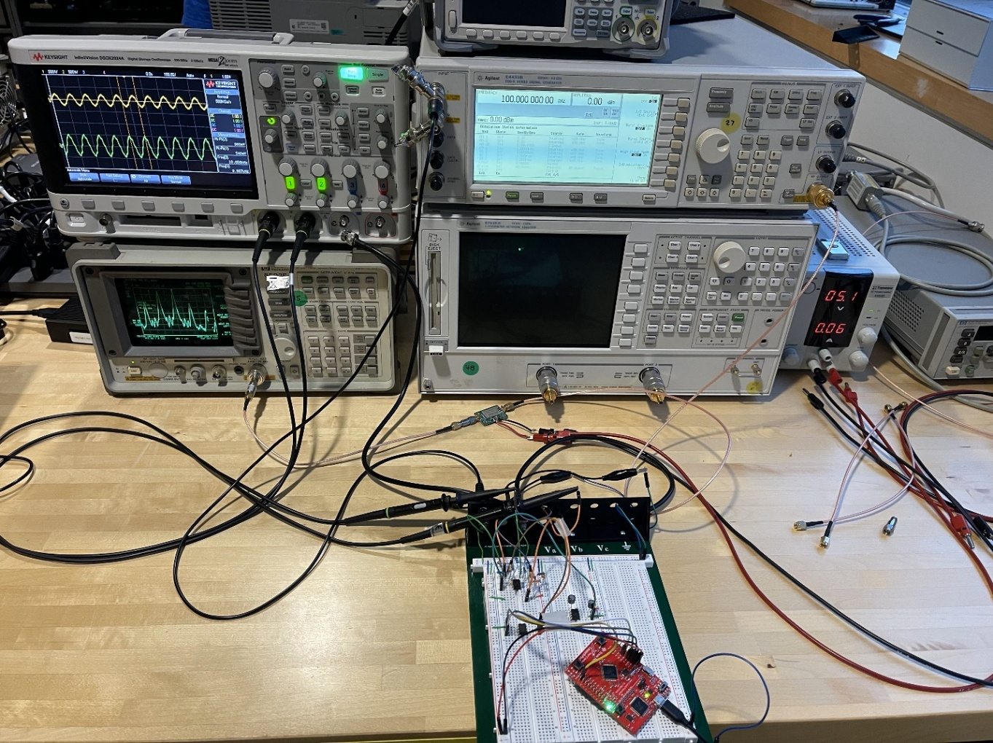
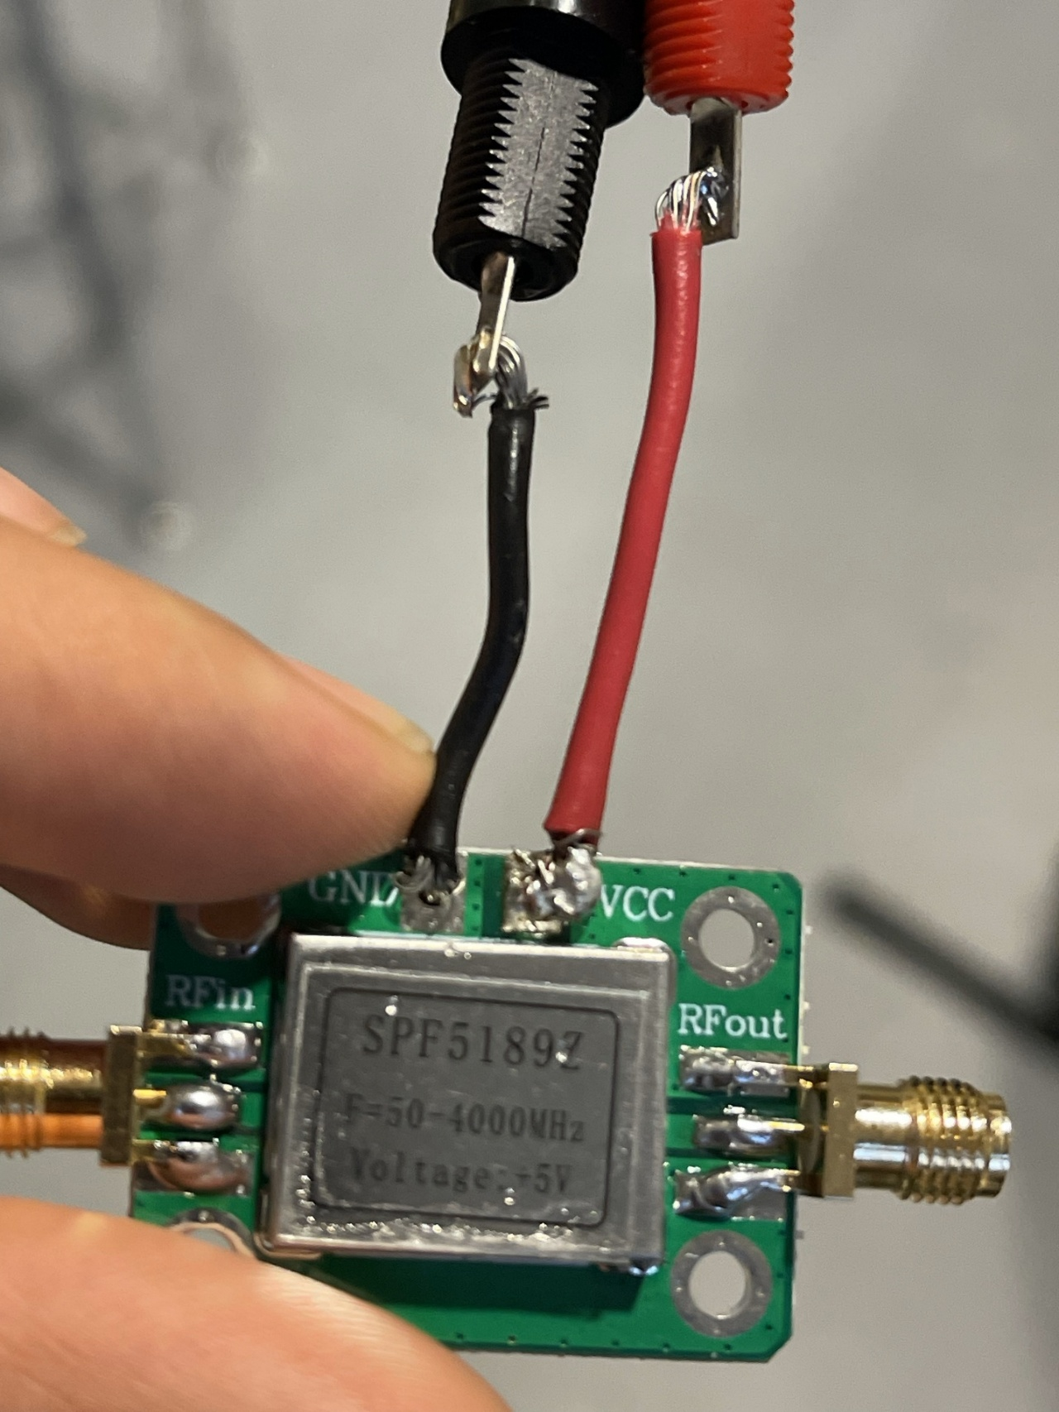
Image 6: Lab 2 setup

Image 7: SPF5189Z Amplifier used for compression sections

